Design Document

# Overview

The current design was chosen to was chosen to be extensible to include other protocols. With that in mind, I created interfaces for the types of codes and the hardware. This way I can use polymorphism to keep my main functions mostly generic as well.

All of the Diagrams are belown.

# Use Case Diagram:

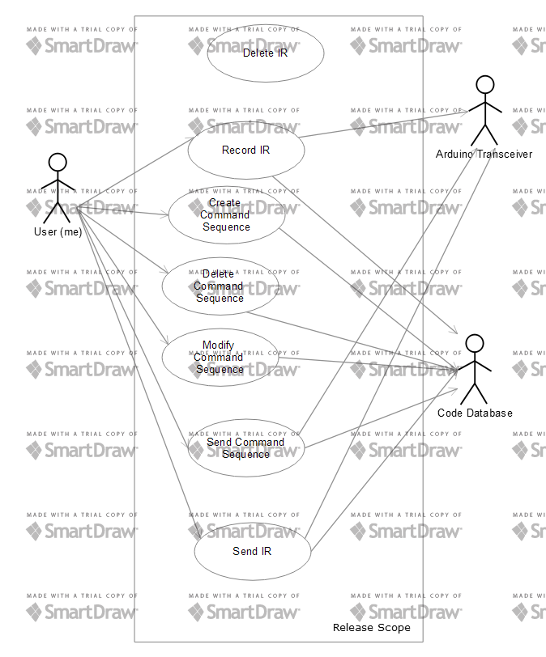

# CRC cards:

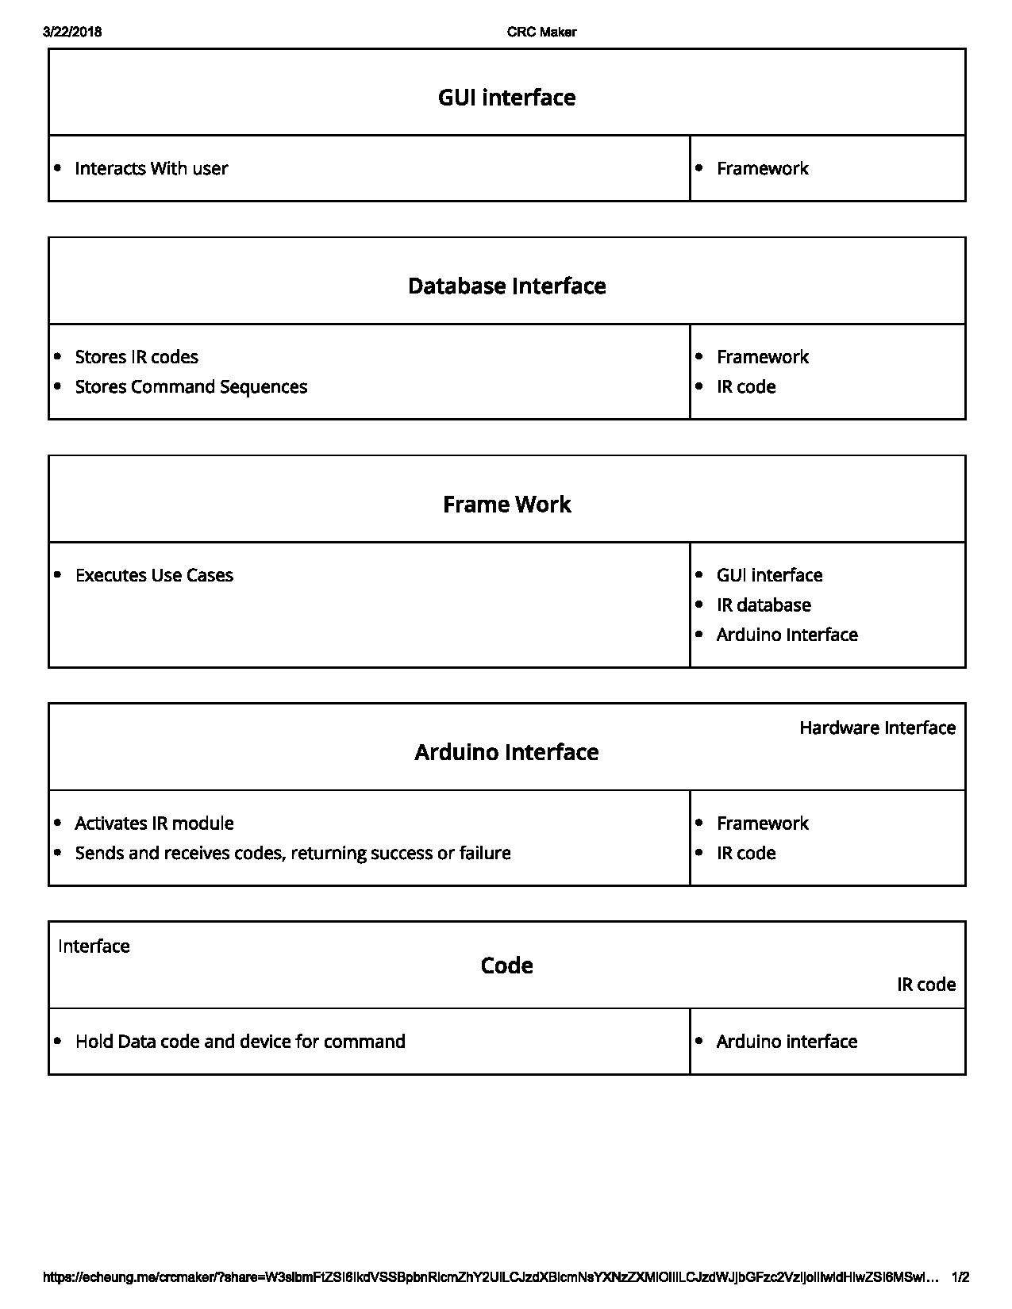

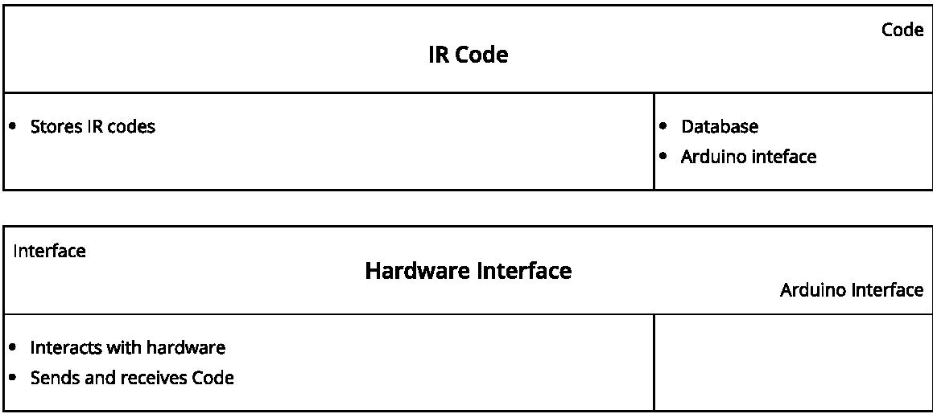

# Class Diagram:

